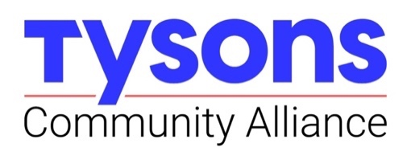

Memorandum
To: Budget and Finance Committee
- Dave Gelfond, Treasurer
- Josh White, Chair
- Pramit Patel
- Joe Mondoro
From: Lezlie Biggers, Director of Budget and Administration
CC: Katie Cristol, CEO; Drew Sunderland, Vice President of Strategy and Research, Rose Araghchy, CPA with R2 Advisors

Re: TCA FY2024 Closeout: Addressing Variances and Key Factors in Underspending

Date: August 16, 2024

The Tysons Community Alliance has closed its books for June 2024, enabling a review of year-end spending. In collaboration with our accountants, R2 Advisors PC, executive leadership has identified major drivers of our FY2024 underspending. Those areas and trends are identified below, along with information about anticipated changes to our FY2025 budget implementation plans – both in substance, of line items among departments, and in practice, in our budget monitoring practices.

Here is an overview of spending by department.
Communications/Marketing:
- The variance of 138k in the Communications/Marketing department is primarily attributed to marketing and promotions expenses totaling 44k, compared to the budgeted amount of 210k. At FY2024 adoption, and in Q1 of FY2024, the TCA planned to complete a branding refresh and launch a paid marketing campaign by the end of the year; these efforts have been moved into FY2025. The brand refresh scope of work is in its final stages and will be complete by end of FY2024, positioning the TCA to realize actual spends (and recruit matching, private sector funds) in FY2025.

- The Communications team and the Research team invested more resources than originally anticipated on the build-out of the Tysons DataHub, an ongoing resource. The majority of the web design and maintenance from the communications budget and additional resources from the supplemental market studies from the research budget supported that successful implementation and kick-off.
Placemaking and Management:
- This department had the largest variance of underspending with 530k remaining balance. This is largely due to the lack of staffing during the fiscal year. Without a director in place for much of the fiscal year, there was less direction to utilize the budget. We are proud that even with that challenge, TCA completed the placemaking framework and delivered a well-attended webinar to share it with our stakeholders in Tysons.
Research and Planning:
- This department had a variance of 227k. As noted above, our key personnel resources were dedicated to the successful creation, implementation and kick-off of the Tysons DataHub in lieu of scoping and contracting for supplemental market studies.
Transportation and Mobility
- This department utilized 70% of its budget. The least utilized budget line item is pilot projects which requires lead time and relationships which were successfully established in the fiscal year.
Administration
- This department had some unforeseen spending required in specialized support for legal, accounting and human resources. Those needs offset our low spending on rental fee and supplies and partial year vacancies.
In reviewing our FY 2024 performance and spending, we also checked the performance of our FY 2025 budget and planning. We are happy to report that as of July, we have a full staff and many contracts in place to carry out our work.
- With 7 full-time and 5 contractor staff, we have committed 76% of our personnel budget. (Any remaining hiring and conversions of contractor to in-house staff is on a hold until there is a better picture of FY 2026 funding levels.)
- 20% of the non-personnel budget is committed to contracts in support of the DataHub, the branding refresh and update, our customer relationship management platform, Copa, Fall Mixed Market, and the Walk, Bike, Roll campaign.

