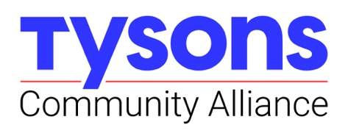
Wednesday, August 21, 2024
9:00 – 10:30 am
Tysons Community Alliance Office with Teams option
NOTE NEW LOCATION: 3rd Floor Conference Room
(elevator bank shortly before TCA office; take elevator to 3rd floor and follow signs)

TCA EXECUTIVE COMMITTEE AGENDA

I. Welcome

II. Operational and CEO Report
- Lease Update and Construction Timeline
- New Staff Introduction: Jason Zogg, Dir. Placemaking
- Program Updates:
  - Placemaking Framework
  - Walk Bike Roll
  - Copa Tysons
- Work Program Monitoring practices: starting with Research & Business Services

III. Budget Briefs: FY24, FY25 and FY26+
- FY24 Close-Out: Analysis of drivers of last year’s carryover
- FY25: July Actuals / Treasurer’s Report
- FY26: $1m Funding Gap and Transportation Service District:
  - Status Report on TSD Funds
  - Impacts of unresolved funding to our program beginning in FY25
  - Exec Committee roles to support addressing this gap

III. Tysons Brand Campaign
- Unveiling new Tysons brand campaign
- Next steps for:
  - Implementation of refreshed brand identity
  - Paid media campaign: Scope and partnerships

IV. Nominating and Governance Committee Presentation
- Recommendations for EC recruitment and succession practices

V. Upcoming Events and EC Action Opportunities
- TCA Board of Directors Meeting: September 18th at The Mather
- Story Time at 1st Stage: September 14th, October 19th and November 16th
- The Mixed Market returns: Help us promote the market, returning this afternoon: Information at https://tysonsva.org/events/tysons-mixed-market; email william@tysonsva.org for promotion tools
- Thought partners needed: Mobility Technology Roundtables (sonali@tysonsva.org)
- Sponsorship opportunity: Imagination Stage @ Tysons; email william@tysonsva.org for more

