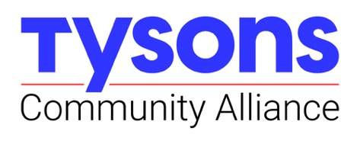
Wednesday, April 24, 2024
9:00 – 10:30 am
Tysons Community Alliance Office (with Zoom option)

TCA EXECUTIVE COMMITTEE AGENDA

I. Welcome

II. Treasurer’s Report:
- April Financials and Close of Year Outlook

III. CEO Report:
- TCA FY2024 “By the Numbers” and Annual Report content preview

III. FY2025 Budget
- Objective: Executive Committee feedback, endorsement of budget for Board of Directors adoption
- Presentation:
  - Refresher on Work Programs
  - Major themes and changes proposed for FY2025
  - Process of developing – and monitoring – the budget
- Executive Committee questions, feedback and discussion

IV. Nominating & Governance Committee
- Organizational Policies
  - Objective: Executive Committee endorsement of policies for Board of Directors adoption
    - Board Member Expectations Document
    - Sponsorship and Advocacy
- Proposed Slate of Directors and Officers
- Future Discussions: Executive Committee composition and succession

VI. FY25 (July – Dec) Meeting Dates for EC
- Thursday July 11th , Wednesday August 21st, Thursday October 10th, Wednesday November 13th , Thursday December 19th (9:00 – 10:30 am, TCA Offices)

V. Closing and Upcoming Events
- Wednesday, June 12th: Board of Directors & Annual Members Meeting, 8:30 – 10:00 am; Tysons Open House concurrent and to follow
- June 26th at Noon: Introducing the Tysons Placemaking Framework: Webinar (link to come)
- Metro Musicians: Thursdays 5-6:30 pm, June 6th – August 29th rotating stations East to West
- Copa Tysons:
  - Launch Event: Meet and Greet with USMNT May 29th 4-5 pm, location TBD
  - 1 Day Family Festival & Viewing Party: 10 am to 6:00 pm on TCC Plaza

