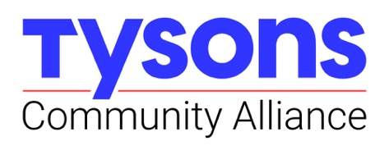
Wednesday, September 13th, 2023
9:00 am
TCA Offices, 1961 Chain Bridge Road, Suite C205B
Tysons Corner Center, Nordstrom wing, 2nd floor

Executive Committee, Tysons Community Alliance Board of Directors
Agenda

Welcome
- TCA FY2024 Q1 Activities and Achievements:
  - Market Study release and earned media
  - Programming and events
  - Placemaking projects: Complete, underway, and emerging

Work Program and Budget Development: FY24 and FY25
- Comments from the Budget & Finance Committee on review of FY2024 Recast Budget
- Staff presentation of FY2024 Work Program
  - Discussion
- Brief staff comments about draft FY2025 submission to Fairfax County, due 9/22
  - Timing of Board of Directors review and approval of FY2025
  - Questions

Organizational Updates & Board Matters
- Transparency and records retention (TCA attorney available for Q&A)
- Updates on new TCA Directors hires
- Membership: Proposed pathways for engaging organizations and individuals in TCA governance and activities

Strategic Plan Update
- Brief update on process and emerging themes

Other Issues and Closing
- Open Discussion
- Board of Directors Meeting 9/27
- Next Executive Committee Meeting 10/25

